Report
1)
Projection Matrix P:
[[ 0.45827554 -0.29474237 -0.01395746 0.0040258 ]
[-0.05085589 -0.0545847 -0.54105993 -0.05237592]
[ 0.10900958 0.17834548 -0.04426782 0.5968205 ]]

2)
2) Fundamental Matrix F:
[[-8.55629053e-07 3.14052683e-05 -7.31606892e-03]
[ 1.42140129e-05 3.14691357e-07 2.59284111e-01]
[ 3.96151277e-03 -2.69985755e-01 1.00000000e+00]]
3) 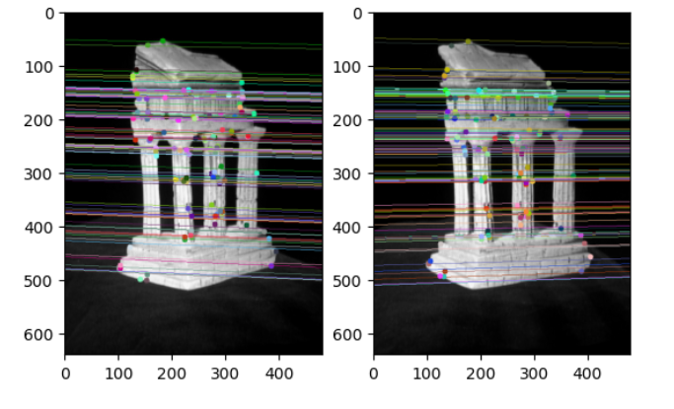

3)
2) Essential Matrix E:
[[ -1.0551774 56.42814506 9.17409425]
[ 35.84410427 1.31422261 -351.3790752 ]
[ -0.79493824 355.80639208 0.42113092]]
4)
Projection Matrix P1:
[[1.5204e+03 0.0000e+00 3.0230e+02 0.0000e+00]
[0.0000e+00 1.5259e+03 2.4690e+02 0.0000e+00]
[0.0000e+00 0.0000e+00 1.0000e+00 0.0000e+00]]
Projection Matrix P2:
[[ 1.39186153e+03 -3.66057834e+01 6.81456482e+02 -1.45375608e+03]
[-2.82826215e+01 1.52525962e+03 2.49226019e+02 -3.64493323e-01]
[-2.56102739e-01 -8.24379544e-04 9.66649216e-01 1.56675614e-01]]

6) visualize_pcd is causing kernel to crash every run.
Custom solution:
